Programming for Games
Tutorial:3

Why this is important

This tutorial is the introduction to basic shader programming and shader concepts. This is essential to all modern graphics programming. Not only to even render anything on the screen but also in how to best manipulate graphics and extract the maximum performance from any hardware. Although there are techniques and other ways of achieving shader functionality (particularly in the DirectXTK) its always necessary to understand the underpinnings of loading and editing your own shader.

What you need to know

(Please note that the example project was created with Visual studio 2017. I recommend you continue to use 2017 throughout the year on these examples and the coursework. )

We are using the same basic example code as last week but looking at a different aspect of it.

At the most basic level there are two main components of modern graphics hardware which we are interested in and interact with directly to produce graphics: The Vertex Processor and the Fragment processor. There are other shader types and processors available but for the moment we will look at this simplistic model. (Note in this diagram the tessellation stage is absent)

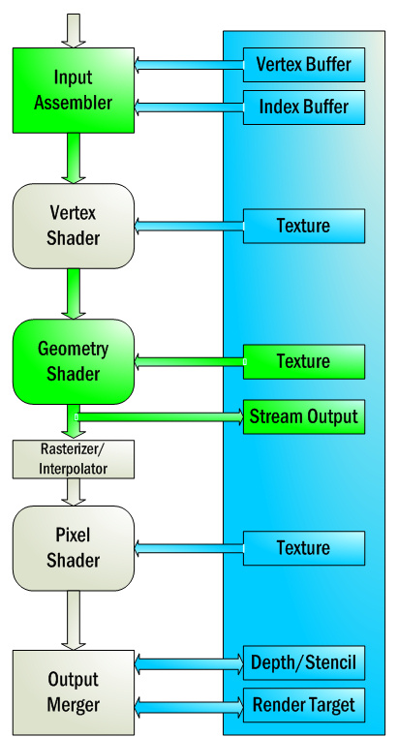

Here we have a representation of the graphics pipeline and we are concerned today with the VERTEX SHADER stage and the PIXEL SHADER (Also referred to as FRAGMENT SHADER) stage.

From last week you remember altering the arrays containing the data representing the triangle. These arrays are fed in at the beginning of the pipeline when we draw the batch object. The data is manipulated by each stage of the pipeline to produce and end result. If we do not specify a vertex and pixel shader to process this data, NOTHING will be rendered at all!

In last weeks example. We allowed DirectXTK to handle the shaders for us. The BatchEffect creates and controls the shader effects for object rendering. Although they are behind the scenes, its still happening. But we still need to be able to create and load in our own shaders manually.

The example has a very simple vertex and fragment shader. The vertex shader does the basic transformations (World, View, and perspective) and the fragment shader assigned a basic color to every pixel in the model but obviously, things can be much more complex than this.

In this example the shaders are calculating the basic transforms and applying them. This is still a valid if perhaps, basic shader. But even with these two shaders alone ,truly spectacular results can be achieved and the majority of effects and polish found in modern game graphics comes from these two stages of the pipeline alone.

We will look at shader management and more advanced techniques later on but the idea here is to understand the basic principles of the vertex and fragment shader.

The first such principle is that the shader is a PROGRAM in its own right that is executed on the hardware (either the vertex or pixel processor) therefor it must be compiled just as our own projects are.

Note: this tutorial example is self contained. We will not be building on this next week but rather be getting a new framework with added complexity. There are things being done in the code to facilitate learning the concepts which are NOT best practice for actual Development.

Tasks:

Task 1:

Look in the Game::CreateDeviceDependantResources method to see where the shader is loaded. Each shader is loaded separately and you will see for example, colour_vs_.cso being loaded in.

But if you open the ASSETS filter you will see the shader file colour_VS.hlsl why is the file extension different? Modern solutions Compile the hlsl files when we build the project into .cso format. So we are loading in the compiled shader rather than the raw HLSL code.

When the shader is compiled the most important thing is error checking and control. Luckily, Visual studio will pickup most errors and report them in the normal fashion, even in your shader! In situations where you compile the shader at runtime, there are no debugging errors so beware of this.

Enter some non-code text into the color.vs file to see the shader compiler throw an error.

As shaders get more and more complex debugging them becomes essential as you can see all we received there was a simple error, Without more information, debugging a complex shader can be an absolute nightmare. We cannot “Step into” the shader as we can with the regular debugger.

Luckily, there are tools available that provide this kind of functionality but are not needed at the moment.

It is important to note that the vertex shader will run once for every single vertex and the pixel shader will run once for every single pixel. You can imagine how many iterations this becomes rendering models with complex geometry or when we come to do more advanced techniques rendering models multiple times. This highlights the need for shader code to be both effective and highly efficient to make the most of the power available.

Task 2:

Now we are going to play with the vertex shader to manipulate the geometry of the triangle. Although the straight transformations will give us the triangle as described, it is possible to write shader code that will manipulate the geometry to give different effects.

Please note that the language used to write shaders may look like C++ and share a lot of the notation but it is actually a language called HLSL

Inside the shader we can manipulate the data in any way we want: For example before the

// Calculate the position of the vertex against the world, view, and projection matrices.
output.position = mul(input.position, worldMatrix);
output.position = mul(output.position, viewMatrix);
output.position = mul(output.position, projectionMatrix);

section add in this line:

input.position.x = input.position.x *2;

This will multiply the x value of every vertex by 2 that passes through the shader. The net effect then is that the object is scaled. In effect we are transforming the object within its own local space.

Feel free to mess with the values here before moving on. Try some different basic transforms.

Its important to note how data is input and output through the vertex shader to the pixel shader.

The section:

Struct InputType
{
float4 position : POSITION;
float4 color : COLOR;
};

struct OutputType
{
float4 position : SV_POSITION;
float4 color : COLOR;
};

Describes the data types we are passing through. We get a Input Type into the vertex shader (passed in) and it returns a outputType which is passed onto the pixel shader.

As we use more and more data the complexity and specificity of these input and output structures will increase but in the long run it should always be specific to the actual shader you are using rather than having redundant data which is not used.

Task 3:

Altering the pixel shader.
At the moment the pixel shader is pretty simple. As you can see it takes in the position and the color and the output color is simple set as the color that comes in as the input data (Which is defined way back in the array in the main code.

Whats actually happening here is some automatic stuff in the background handled by DirectX. Since its only Getting in Vertex color and position information, Direct X will calculate a blended colour automatically based on the nearest 3 Vertices.

Change the vertex colours of the object in the render function to see the automatic colour blending with different colours with each vertex.

Task 4:
Alter the Pixel shader code to override the colour information and show the triangle as one solid colour of your own choosing.

Task 5:

In the same way we altered the vertex shader consider how you could alter the pixel shader to VARY the color rendered with the position of the pixel! For this purpose I have created another variable input into the pixel shader from the vertex shader called screenPosition. It is not possible to use input.position for this purpose due to how its tied into the pixel shader operation, but by duplicating this information into a new variable. It works. All the information is there, you just need to decide how to use input.color with the input.screenPosition to change the result. The position may not be as you suspect with respect to where the origin is. Try an experiment and see what effect you can make. (An object that fills more of the screen will show a more visible result)

Note that the position available to us in the vertex shader is in screen space. Not world space. So the values will tend to be between 0 and 1 (ish) for the triangle. See what you can achieve!

Struggling?
If you are finding any point of this difficult. Please refer to the person running the lab.

Key Points!

- Vertex and pixel shaders are separate programs to your main application which are loaded, compiled and then run on the GPU when you run your application.

- Debugging and otherwise troubleshooting Shaders is an art to itself. Sometimes it can be difficult to determine why things or going wrong.

- Vertex shader programs operate once per Vertex, Pixel shaders operate once per pixel. Every frame.

Did you know?

The Programmable shader pipeline became available with the Directx 8.0 and offered an alternative to what’s known as the “Fixed function pipeline”.

